|  |  |
| --- | --- |
|  | Use Case Document |
| 5/7/2013 | Graduate Capstone |

Table of Contents

1 Introduction 2

1.1 Intended Document 2

1.2 Resources 2

1.3 Revision History 2

2 Use Cases 3

2.1 Phone Application 3

UC-01: See Main Menu 3

UC-02: User Sign In 4

UC-03: User Sign Out 5

UC-04: Browse All Companies 6

UC-05: View Company Information 7

UC-06: View Survey Information 8

UC-07: Take Survey 9

UC-08: Answer Survey Question 10

UC-10: User Search For Companies 11

2.2 Web Services 12

UC-09: Get List of Companies 12

UC-22: Add / Edit / Delete Code Type 13

UC-23: Add / Edit / Delete Code 14

UC-24: Edit / Delete User 15

UC-25: Add / Edit / Delete Company 16

UC-26: Add / Edit / Delete Survey 17

UC-27: Add / Edit / Delete Revision 18

UC-28: Add / Edit / Delete Command Element 19

UC-29: Add / Edit / Delete Command Identifier 20

UC-30: Add / Edit / Delete Form Element 21

UC-31: Add / Edit / Delete Form Element Attribute 22

UC-32: Add / Edit / Delete Form Element Option 23

2.3 Administrator Web-Application 24

UC-11: Add / Edit / Delete Code Types 24

UC-12: Add / Edit / Delete Code 25

UC-13: Add / Edit / Delete Company 26

UC-14: Add / Edit / Delete Survey 27

UC-15: Add / Edit / Delete Revision 28

UC-16: Add / Edit / Delete Command Element 29

UC-17: Add / Edit / Delete Command Identifier 30

UC-18: Add / Edit / Delete Form Element 31

UC-19: Add / Edit / Delete Form Element Attribute 32

UC-20: Add / Edit / Delete Form Element Option 33

UC-21: Add / Edit / Delete User 34

# 1 Introduction

This document is a resource containing all the use cases that are involved with the project.

## 1.1 Intended Document

This document is intended for individuals with a medium level of technical background.

## 1.2 Resources

None

## 1.3 Revision History

|  |  |  |  |
| --- | --- | --- | --- |
| Name | Date | Reason For Change | Version |
| Andy Bottom | 04/12/2013 | Started making the document; Created First Couple Use Cases | 0.1 |
| Andy Bottom | 04/16/2013 | Continued making document. Implemented the next several use cases and requirements | 0.1.1 |
| Andy Bottom | 04/27/2013 | Implement almost all of the use cases and diagrams | 0.2 |
| Andy Bottom | 05/01/2013 | Finished first version | 1.0 |

# 2 Use Cases

Below is a list of use cases for the phone application, web services and the web admin.

## 2.1 Phone Application

### UC-01: See Main Menu

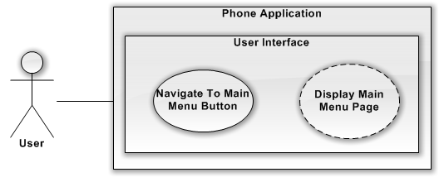

|  |  |
| --- | --- |
| Use Case Name | UC-01: See Main Menu |
| Purpose | How the user can get to the main menu |
| Summary | The User will get to the main menu |
| Work Products | Phone Application |
| Users/Actors | User |
| Entry Criteria | User is viewing a screen in the application. |
| Preconditions | A User is on any screen in the application. |
| Basic Course of Events | 01: User hit the home / menu button on the phone.  02: The main menu screen will be displayed |
| Alternative Paths | AP-01: The application is not started and the user starts the application.  AP-02: The application should show the main menu on start-up |
| Postconditions | The about us page content has been updated |
| Exit Criteria | Admin would see the content and be happy with it. |

### UC-02: User Sign In

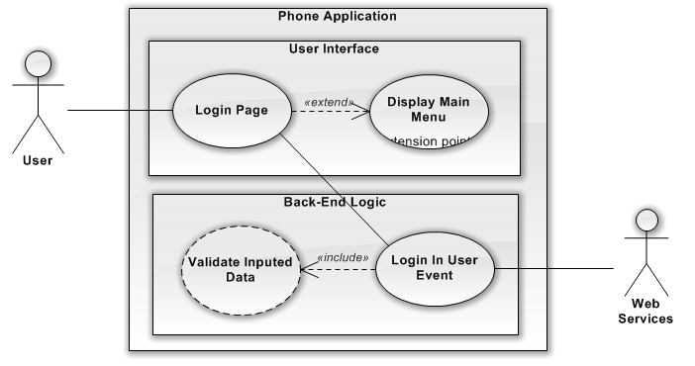

|  |  |
| --- | --- |
| Use Case Name | UC-02: User Sign In |
| Purpose | Gives the user the ability to log in |
| Summary | Sign In Feature |
| Rationale | This way a user can take advantage of better features of the system. |
| Work Products | Phone Application |
| Users/Actors | User; Web Services |
| Entry Criteria | The User has navigated to the Sign In Screen |
| Preconditions | The User is not signed in already in the device |
| Basic Course of Events | 01: User enters their username  02: User enters their password / pin  03: User presses the submit button  03-1: Upon Submit, the application will verify the inputs from the user. 03-2: Upon a successful verification it sends sign in request to the server.  04: User waits for response to return.  04-1: The services will verify that the user and password match.  04-2: Upon a successful match, the services will return the user information to login.  05: Successful Credentials received  06: The phone creates a cookie to store the logged in user.  07: User sees successful login message and is directed to the main menu. |
| Alternative Paths | AP-03-1: If a user does not submit a valid username or password, upon submit, it will display an error to the user. (Such as blank would cause error)  AP-04-2: Upon a unsuccessful match the system returns error back and the error is then sent to user to try again. |
| Postconditions | The user is on the main menu page and is logged in to their user account. |
| Exit Criteria | User is logged in. |

### UC-03: User Sign Out

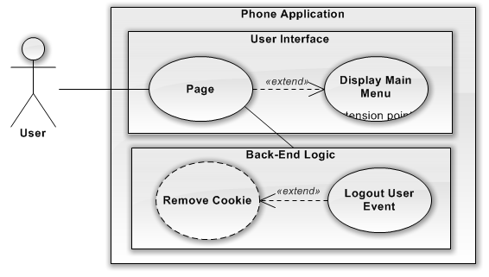

|  |  |
| --- | --- |
| Use Case Name | UC-03: User Sign Out |
| Description | The user can sign out of their account in the application and become just an anonymous user |
| Work Products | Phone Application |
| Users/Actors | User |
| Assumptions | The User has navigated to the Sign Out Screen |
| Preconditions | The User is already signed in |
| Steps | 01: User Clicks the Logout Button  01-1: Message Prompts are you sure.  01-2: User clicks accept  02: Cookie is deleted from phone.  03: Message Returned saying that they were successfully logged out.  04: User returned to main menu |
| Variations | AP-02: There may be a need to send information to the web service to set some sort of properties. In this case, they will need to wait for this to successes.  AP-01-2: If user clicks cancel, then the logout process is stopped and the user is returned to the screen they were on and are still logged in. |
| Postconditions | The user is no longer logged in on the application. |
| Exit Criteria | User is logged out. |
| Notes | There may or may not be needed information to store about logout information. So Web Services at this time will not be updated. |

### 

### UC-04: Browse All Companies

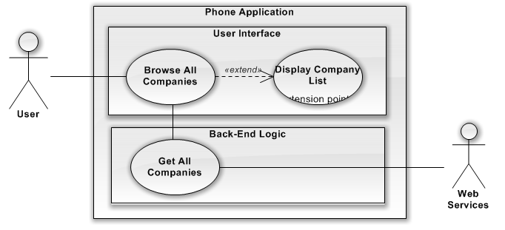

|  |  |
| --- | --- |
| Use Case Name | UC-04: Browse All Companies |
| Description | A Screen that lists all the companies that are in the system. |
| Work Products | Phone Application |
| Users/Actors | User; Web Services |
| Assumptions | The User navigates to Browse All Companies Page |
| Preconditions | None |
| Steps | 01: The User Navigates to the Browse All Companies Page  01-1: Sends request to webserver to obtain a list of all the companies  02: User sees loading icon, to wait.  02-1: The app receives the requests, parses it and outputs to user  03: User sees a list of companies |
| Variations | AP-02-1: If the app receives error, then it should handle error to try again or that it is not available.  AP-01-1: If there is a local cache of the companies, then it should parse that. |
| Postconditions | User sees a list of companies |
| Exit Criteria | Companies are displayed |
| Notes | The ability to sort companies by alpha, category type, etc… would be nice. |
| References | UC-09; |

### UC-05: View Company Information

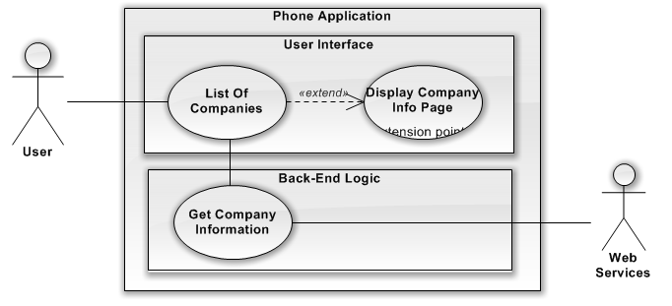

|  |  |
| --- | --- |
| Use Case Name | UC-05: View Company Information |
| Description | Displays a screen containing background information about a specific company |
| Work Products | Phone Application |
| Users/Actors | User |
| Assumptions | The User chooses a company to see the information about |
| Preconditions | The user has chosen a company |
| Steps | 01: The User Chooses a company to see information about.  01-1: A Request is sent to web server to get information about the company  02: User sees waiting icon  02-1: App receives information and parses it and outputs to user.  03: The Company information page is displayed to the user |
| Variations | AP-02-1: If the app receives error, then it should handle error to try again or that it is not available.  AP-01-1: If there is a local cache of the company, then it should parse that. |
| Postconditions | User sees the Company Information Page |
| Exit Criteria | Company is displayed |
| Note | If the company is already stored in cache, then there would be no need to query the web services again. |

### UC-06: View Survey Information

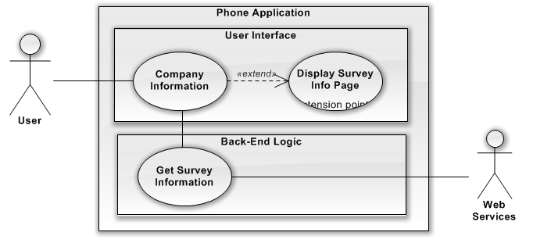

|  |  |
| --- | --- |
| Use Case Name | UC-06: View Survey Information |
| Description | Displays a screen containing information about a specific Survey of a Company |
| Work Products | Phone Application |
| Users/Actors | User |
| Assumptions | The User chooses a Survey to see further information |
| Preconditions | The user has chosen a survey |
| Steps | 01: The User Chooses a survey to see information about.  01-1: A Request is sent to web server to get information about the company  02: User sees waiting icon  02-1: App receives information and parses it and outputs to user.  03: The Survey information page is displayed to the user |
| Variations | AP-02-1: If the app receives error, then it should handle error to try again or that it is not available.  AP-01-1: If there is a local cache of the survey, then it should parse that. |
| Postconditions | User sees the Survey Information Page |
| Exit Criteria | Survey Information is displayed |
| Notes | If the survey information is already stored in cache, then there would be no need to query the web services again. |

### UC-07: Take Survey

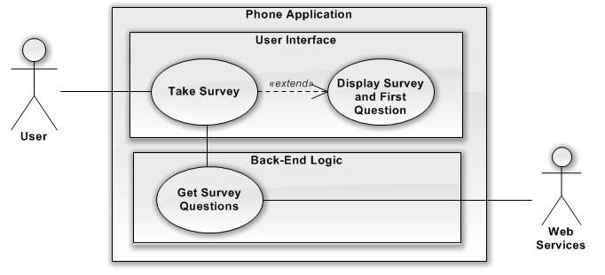

|  |  |
| --- | --- |
| Use Case Name | UC-07: Take Survey |
| Description | Start the Survey |
| Work Products | Phone Application |
| Users/Actors | User |
| Assumptions | The User is on the Survey Page |
| Preconditions | The User is on a specific survey for a specific company |
| Steps | 01: The User Chooses to Start the Survey  01-1: A Request is sent to web server to get the survey questions. It sends along user’s logged in ID if it is logged in.  02: User sees waiting icon  02-1: App receives information and parses it and outputs to user.  03: The Survey Questions will be displayed to the user to take the survey |
| Variations | AP-01-1-A: If a user is logged in and then it will receive questions with some answers already filled out since we know the information already.  AP-01-1-B: If a user is anonymous then it will receive all questions of the survey |
| Postconditions | User sees the Survey of a Company |
| Exit Criteria | Survey is displayed |

### UC-08: Answer Survey Question

@TODO – This use case seems a little wonky to me.

|  |  |
| --- | --- |
| Use Case Name | UC-08: Answer Survey Question |
| Description | Answering a Question |
| Work Products | Phone Application |
| Users/Actors | User |
| Assumptions | The user is currently taking a survey |
| Preconditions | A user is taking a unique survey and is on a unique question |
| Steps | 01: A question is displayed to the user along with a input element (radio, select box, textbox, etc…)  01-1: A Request is sent to web server to get the survey questions. It sends along a user’s logged in ID if it is logged in.  02: User sees waiting icon  02-1: App receives information and parses it and outputs to user.  03: The Survey Questions will be displayed to the user to take the survey |
| Variations | AP-01-1-A: If a user is logged in and then it will receive questions with some answers already filled out since we know the information already.  AP-01-1-B: If a user is anonymous then it will receive all questions of the survey |
| Postconditions | User sees the Survey of a Company |
| Exit Criteria | Survey is displayed |

### UC-10: User Search For Companies

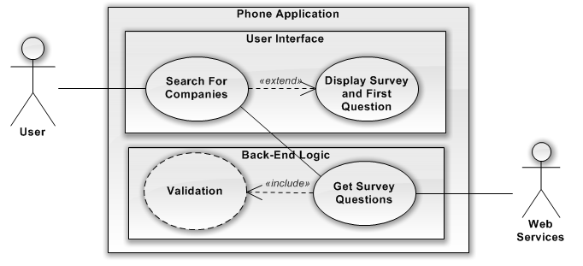

|  |  |
| --- | --- |
| Use Case Name | UC-10: User Search For Companies |
| Description | User may also use a search to lookup a company. They will use the form to select certain parameters to search on including a search text; company type; |
| Work Products | Phone Application |
| Users/Actors | User; Web Services |
| Assumptions | The User has navigated to the search for company page. |
| Preconditions | None; |
| Steps | 01: The User fills out the Search for Company Page;  01-01: This may include searching for a string  01-02: Searching by Company Category type.  02: User Clicks the Search button  03: User see’s message, “Searching, Please Wait.”  03-01: Search is sent to web service along with the parameters;  03-02: Response is received  03-03: The Response is parsed in put into Company Objects  03-04: The company objects will be outputted as a list for the user.  04: The List of Company Results is displayed. |
| Variations | AP-03-01: If the app receives error, then it should handle error to try again or that it is not available.  AP-03-02: If Response contains no company objects, message will say, “There were no companies found. Please Change Search Criteria.” |
| Postconditions | A list of companies has been obtained. |
| Exit Criteria | User sees the Company Search Results Page. |
| References | UC-09; |

### 

## 2.2 Web Services

### UC-09: Get List of Companies

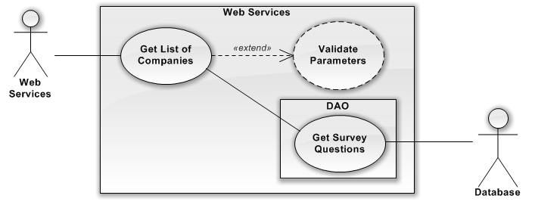

|  |  |
| --- | --- |
| Use Case Name | UC-09: Get List Of Companies |
| Description | The Web Services method that gets call to get a list of Companies pending on the certain criteria |
| Work Products | Web Services; |
| Users/Actors | Web Services; Database; |
| Assumptions | Received Parameters is Validated; |
| Preconditions | The Method gets called; Receives Certain Search Criteria |
| Steps | 01: Web Services Get List of Companies gets Called  02: Validates received parameters  03: Calls DAO to get list of companies from database and passes the searched criteria  03-01: DAO calls the company table and queries on the received parameters. Returns a list of Company Objects  04: List of Company Objects are returned. |
| Variations | AP-03-01: If can’t connect to database, it will timeout and return error. |
| Postconditions | A list of company objects is returned |
| Exit Criteria | Web Services wait for next call |
| Notes | The types of parameters may include, user favorites, company categories, search based on name or description. |

### UC-22: Add / Edit / Delete Code Type

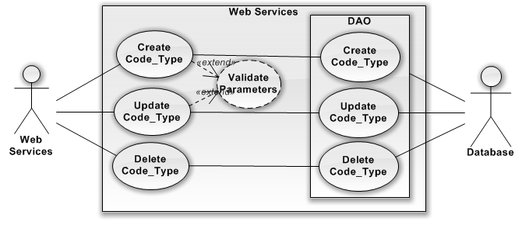

|  |  |
| --- | --- |
| Use Case Name | UC-22: Add / Edit / Delete Code Type |
| Description | The Web Services method that gets called to create, edit or delete a Code Type Object. |
| Work Products | Web Services; |
| Users/Actors | Web Services; Database; |
| Assumptions | Received Parameters is Validated; |
| Preconditions | The Method gets called; Receives Certain Parameters Criteria |
| Steps | 01: The Web Service Method Add / Edit / Delete Code Type gets called  02: Validates received parameters  03: Calls DAO to perform the needed logic in the database  03-01: DAO calls the Code_Type table and queries on the received parameters. Returns success message  04: Return Success Message |
| Variations | AP-03-01: If can’t connect to database, it will timeout and return error. |
| Postconditions | The correct database action for the Code_Type table has been performed |
| Exit Criteria | Web Services wait for next call |

### UC-23: Add / Edit / Delete Code

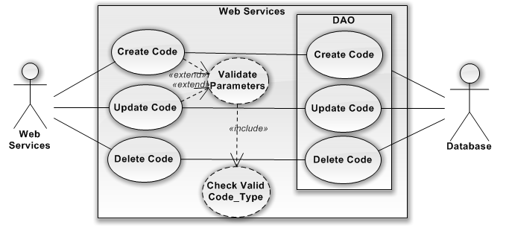

|  |  |
| --- | --- |
| Use Case Name | UC-23: Add / Edit / Delete Code |
| Description | The Web Services method that gets called to create, edit or delete a Code Object. |
| Work Products | Web Services; |
| Users/Actors | Web Services; Database; |
| Assumptions | Received Parameters is Validated; |
| Preconditions | The Method gets called; Receives Certain Parameters Criteria |
| Steps | 01: The Web Service Method Add / Edit / Delete Code gets called  02: Validates received parameters  03: Calls DAO to perform the needed logic in the database  03-01: DAO calls the Code table and queries on the received parameters. Returns success message  04: Return Success Message |
| Variations | AP-03-01: If can’t connect to database, it will timeout and return error. |
| Postconditions | The correct database action for the Code table has been performed |
| Exit Criteria | Web Services wait for next call |

### UC-24: Edit / Delete User

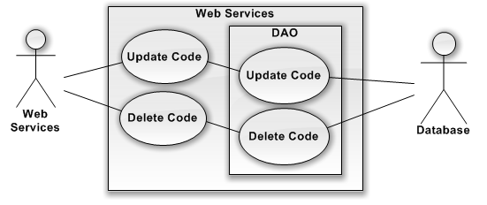

|  |  |
| --- | --- |
| Use Case Name | UC-24: Edit / Delete Code |
| Description | The Web Services method that gets called to edit or delete a User Object. |
| Work Products | Web Services; |
| Users/Actors | Web Services; Database; |
| Assumptions | Received Parameters is Validated; |
| Preconditions | The Method gets called; Receives Certain Parameters Criteria |
| Steps | 01: The Web Service Method Edit / Delete User gets called  02: Validates received parameters  03: Calls DAO to perform the needed logic in the database  03-01: DAO calls the User table and queries on the received parameters. Returns success message  04: Return Success Message |
| Variations | AP-03-01: If can’t connect to database, it will timeout and return error. |
| Postconditions | The correct database action for the User table has been performed |
| Exit Criteria | Web Services wait for next call |

### UC-25: Add / Edit / Delete Company

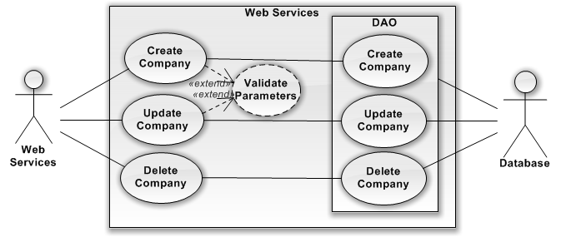

|  |  |
| --- | --- |
| Use Case Name | UC-25: Add / Edit / Delete Company |
| Description | The Web Services method that gets called to create, edit or delete a Company Object. |
| Work Products | Web Services; |
| Users/Actors | Web Services; Database; |
| Assumptions | Received Parameters is Validated; |
| Preconditions | The Method gets called; Receives Certain Parameters Criteria |
| Steps | 01: The Web Service Method Add / Edit / Delete Company gets called  02: Validates received parameters  03: Calls DAO to perform the needed logic in the database  03-01: DAO calls the Company table and queries on the received parameters. Returns success message  04: Return Success Message |
| Variations | AP-03-01: If can’t connect to database, it will timeout and return error. |
| Postconditions | The correct database action for the Company table has been performed |
| Exit Criteria | Web Services wait for next call |

### UC-26: Add / Edit / Delete Survey

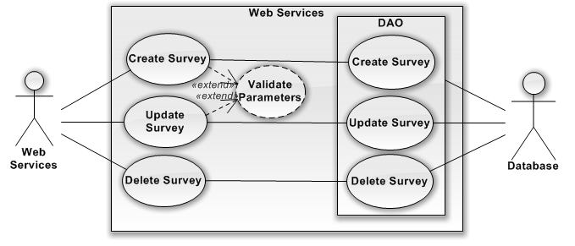

|  |  |
| --- | --- |
| Use Case Name | UC-26: Add / Edit / Delete Survey |
| Description | The Web Services method that gets called to create, edit or delete a Survey Object. |
| Work Products | Web Services; |
| Users/Actors | Web Services; Database; |
| Assumptions | Received Parameters is Validated; |
| Preconditions | The Method gets called; Receives Certain Parameters Criteria |
| Steps | 01: The Web Service Method Add / Edit / Delete Survey gets called  02: Validates received parameters  03: Calls DAO to perform the needed logic in the database  03-01: DAO calls the Survey table and queries on the received parameters. Returns success message  04: Return Success Message |
| Variations | AP-03-01: If can’t connect to database, it will timeout and return error. |
| Postconditions | The correct database action for the Survey table has been performed |
| Exit Criteria | Web Services wait for next call |

### UC-27: Add / Edit / Delete Revision

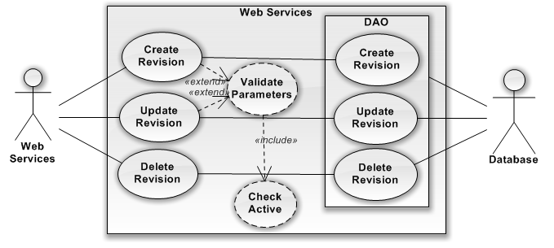

|  |  |
| --- | --- |
| Use Case Name | UC-27: Add / Edit / Delete Revision |
| Description | The Web Services method that gets called to create, edit or delete a Revision Object. |
| Work Products | Web Services; |
| Users/Actors | Web Services; Database; |
| Assumptions | Received Parameters is Validated; |
| Preconditions | The Method gets called; Receives Certain Parameters Criteria |
| Steps | 01: The Web Service Method Add / Edit / Delete Revision gets called  02: Validates received parameters  03: Calls DAO to perform the needed logic in the database  03-01: DAO calls the Revision table and queries on the received parameters. Returns success message  04: Return Success Message |
| Variations | AP-03-01: If can’t connect to database, it will timeout and return error. |
| Postconditions | The correct database action for the Revision table has been performed |
| Exit Criteria | Web Services wait for next call |

### UC-28: Add / Edit / Delete Command Element

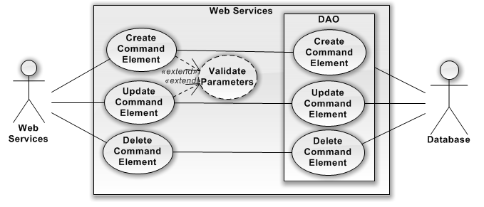

|  |  |
| --- | --- |
| Use Case Name | UC-28: Add / Edit / Delete Command Element |
| Description | The Web Services method that gets called to create, edit or delete a Command Element Object. |
| Work Products | Web Services; |
| Users/Actors | Web Services; Database; |
| Assumptions | Received Parameters is Validated; |
| Preconditions | The Method gets called; Receives Certain Parameters Criteria |
| Steps | 01: The Web Service Method Add / Edit / Delete Command Element gets called  02: Validates received parameters  03: Calls DAO to perform the needed logic in the database  03-01: DAO calls the Command Element table and queries on the received parameters. Returns success message  04: Return Success Message |
| Variations | AP-03-01: If can’t connect to database, it will timeout and return error. |
| Postconditions | The correct database action for the Command Element table has been performed |
| Exit Criteria | Web Services wait for next call |

### UC-29: Add / Edit / Delete Command Identifier

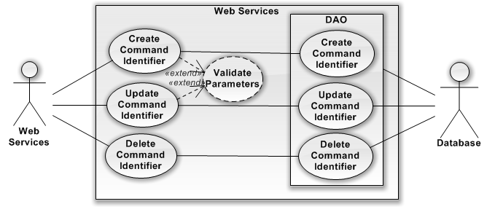

|  |  |
| --- | --- |
| Use Case Name | UC-29: Add / Edit / Delete Command Identifier |
| Description | The Web Services method that gets called to create, edit or delete a Command Identifier Object. |
| Work Products | Web Services; |
| Users/Actors | Web Services; Database; |
| Assumptions | Received Parameters is Validated; |
| Preconditions | The Method gets called; Receives Certain Parameters Criteria |
| Steps | 01: The Web Service Method Add / Edit / Delete Command Identifier gets called  02: Validates received parameters  03: Calls DAO to perform the needed logic in the database  03-01: DAO calls the Command Identifier table and queries on the received parameters. Returns success message  04: Return Success Message |
| Variations | AP-03-01: If can’t connect to database, it will timeout and return error. |
| Postconditions | The correct database action for the Command Identifier table has been performed |
| Exit Criteria | Web Services wait for next call |

### UC-30: Add / Edit / Delete Form Element

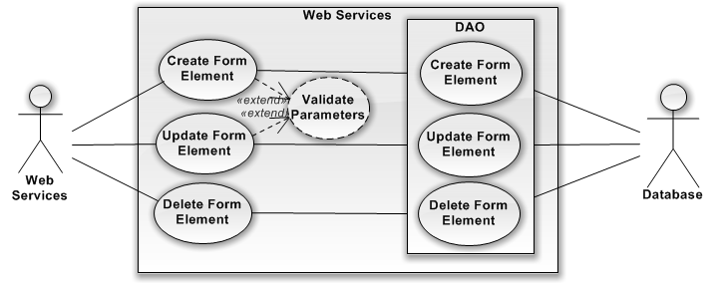

|  |  |
| --- | --- |
| Use Case Name | UC-30: Add / Edit / Delete Form Element |
| Description | The Web Services method that gets called to create, edit or delete Form Element Object. |
| Work Products | Web Services; |
| Users/Actors | Web Services; Database; |
| Assumptions | Received Parameters is Validated; |
| Preconditions | The Method gets called; Receives Certain Parameters Criteria |
| Steps | 01: The Web Service Method Add / Edit / Delete Form Element gets called  02: Validates received parameters  03: Calls DAO to perform the needed logic in the database  03-01: DAO calls the Form Element table and queries on the received parameters. Returns success message  04: Return Success Message |
| Variations | AP-03-01: If can’t connect to database, it will timeout and return error. |
| Postconditions | The correct database action for the Form Element table has been performed |
| Exit Criteria | Web Services wait for next call |

### UC-31: Add / Edit / Delete Form Element Attribute

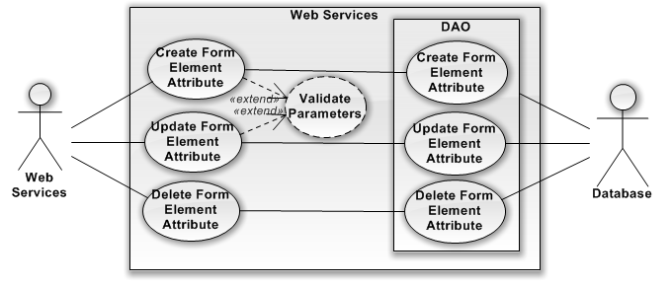

|  |  |
| --- | --- |
| Use Case Name | UC-31: Add / Edit / Delete Form Element Attribute |
| Description | The Web Services method that gets called to create, edit or delete Form Element Attribute Object. |
| Work Products | Web Services; |
| Users/Actors | Web Services; Database; |
| Assumptions | Received Parameters is Validated; |
| Preconditions | The Method gets called; Receives Certain Parameters Criteria |
| Steps | 01: The Web Service Method Add / Edit / Delete Form Element Attribute gets called  02: Validates received parameters  03: Calls DAO to perform the needed logic in the database  03-01: DAO calls the Form Element Attribute table and queries on the received parameters. Returns success message  04: Return Success Message |
| Variations | AP-03-01: If can’t connect to database, it will timeout and return error. |
| Postconditions | The correct database action for the Form Element Attribute table has been performed |
| Exit Criteria | Web Services wait for next call |

### UC-32: Add / Edit / Delete Form Element Option

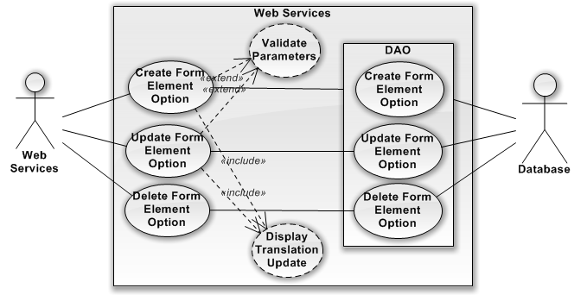

|  |  |
| --- | --- |
| Use Case Name | UC-32: Add / Edit / Delete Form Element Option |
| Description | The Web Services method that gets called to create, edit or delete Form Element Option Object. |
| Work Products | Web Services; |
| Users/Actors | Web Services; Database; |
| Assumptions | Received Parameters is Validated; |
| Preconditions | The Method gets called; Receives Certain Parameters Criteria |
| Steps | 01: The Web Service Method Add / Edit / Delete Form Element Option gets called  02: Validates received parameters  03: Calls DAO to perform the needed logic in the database  03-01: DAO calls the Form Element Option table and queries on the received parameters. Returns success message  04: Return Success Message |
| Variations | AP-03-01: If can’t connect to database, it will timeout and return error. |
| Postconditions | The correct database action for the Form Element Option table has been performed |
| Exit Criteria | Web Services wait for next call |

## 2.3 Administrator Web-Application

### UC-11: Add / Edit / Delete Code Types

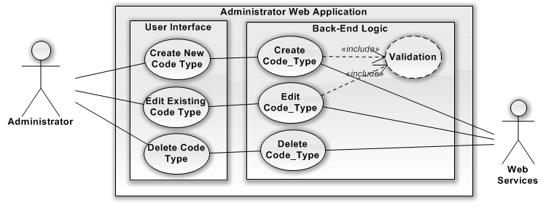

|  |  |
| --- | --- |
| Use Case Name | UC-11: Add / Edit/ Delete Code Types |
| Description | Administrator can manage all CRUD operations for the Code_Type table |
| Work Products | Admin Web App; |
| Users/Actors | Administrator; Web Services; |
| Assumptions | Administrator is logged in; |
| Preconditions | None; |
| Steps | 01: Use Inputs Needed values for the Code Types  02: User Clicks Submit  03: User Sees Waiting Message  03-01: Validation of all inputted values  03-02: Request made to Web Services  03-03: Response is received and information is parsed.  04: Page is refreshed to show the updated content |
| Variations | AP-03-01: If any fields are invalid, it will output error message to user.  AP-03-02: If can’t connect to database, it will timeout and return error. |
| Postconditions | CRUD Operations is performed on Code Types |
| Exit Criteria | None |

### UC-12: Add / Edit / Delete Code

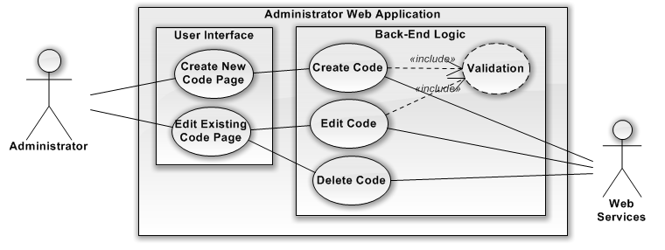

|  |  |
| --- | --- |
| Use Case Name | UC-12: Add / Edit/ Delete Code |
| Description | The Administrator can manage all CRUD operations of the Codes Table |
| Work Products | Admin Web App; |
| Users/Actors | Administrator; Web Services; |
| Assumptions | Administrator is logged in; |
| Preconditions | None; |
| Steps | 01: Use Inputs Needed values for the Code  02: User Clicks Submit  03: User Sees Waiting Message  03-01: Validation of all inputted values  03-02: Request made to Web Services  03-03: Response is received and information is parsed.  04: Page is refreshed to show the updated content |
| Variations | AP-03-01: If any fields are invalid, it will output error message to user.  AP-03-02: If can’t connect to database, it will timeout and return error. |
| Postconditions | CRUD Operations is performed on Codes |
| Exit Criteria | None |

### UC-13: Add / Edit / Delete Company

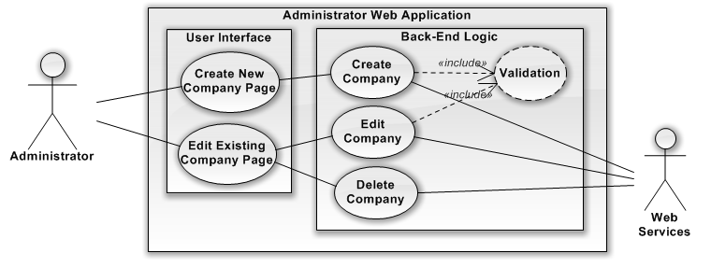

|  |  |
| --- | --- |
| Use Case Name | UC-13: Add / Edit/ Delete Company |
| Description | The Administrator can manage all CRUD operations of the Company Table |
| Work Products | Admin Web App; |
| Users/Actors | Administrator; Web Services; |
| Assumptions | Administrator is logged in; |
| Preconditions | None; |
| Steps | 01: Use Inputs Needed values for the Company  02: User Clicks Submit  03: User Sees Waiting Message  03-01: Validation of all inputted values  03-02: Request made to Web Services  03-03: Response is received and information is parsed.  04: Page is refreshed to show the updated content |
| Variations | AP-03-01: If any fields are invalid, it will output error message to user.  AP-03-02: If can’t connect to database, it will timeout and return error. |
| Postconditions | CRUD Operations is performed on Company |
| Exit Criteria | None |

### UC-14: Add / Edit / Delete Survey

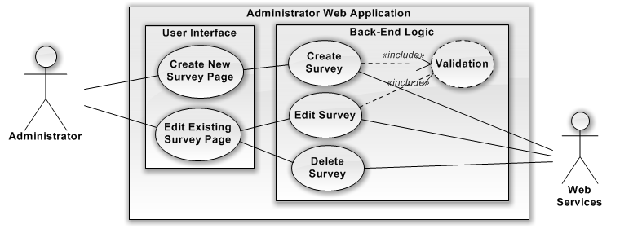

|  |  |
| --- | --- |
| Use Case Name | UC-14: Add / Edit/ Delete Survey |
| Description | The Administrator can manage all CRUD operations of the Survey Table |
| Work Products | Admin Web App; |
| Users/Actors | Administrator; Web Services; |
| Assumptions | Administrator is logged in; |
| Preconditions | None; |
| Steps | 01: Use Inputs Needed values for the Survey  02: User Clicks Submit  03: User Sees Waiting Message  03-01: Validation of all inputted values  03-02: Request made to Web Services  03-03: Response is received and information is parsed.  04: Page is refreshed to show the updated content |
| Variations | AP-03-01: If any fields are invalid, it will output error message to user.  AP-03-02: If can’t connect to database, it will timeout and return error. |
| Postconditions | CRUD Operations is performed on Survey |
| Exit Criteria | None |

### UC-15: Add / Edit / Delete Revision

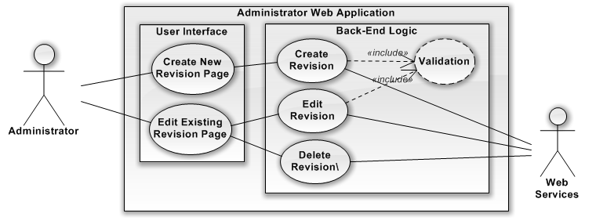

|  |  |
| --- | --- |
| Use Case Name | UC-15: Add / Edit/ Delete Revision |
| Description | The Administrator can manage all CRUD operations of the Revision Table |
| Work Products | Admin Web App; |
| Users/Actors | Administrator; Web Services; |
| Assumptions | Administrator is logged in; |
| Preconditions | None; |
| Steps | 01: Use Inputs Needed values for the Revision  02: User Clicks Submit  03: User Sees Waiting Message  03-01: Validation of all inputted values  03-02: Request made to Web Services  03-03: Response is received and information is parsed.  04: Page is refreshed to show the updated content |
| Variations | AP-03-01: If any fields are invalid, it will output error message to user.  AP-03-02: If can’t connect to database, it will timeout and return error. |
| Postconditions | CRUD Operations is performed on Revision |
| Exit Criteria | None |

### UC-16: Add / Edit / Delete Command Element

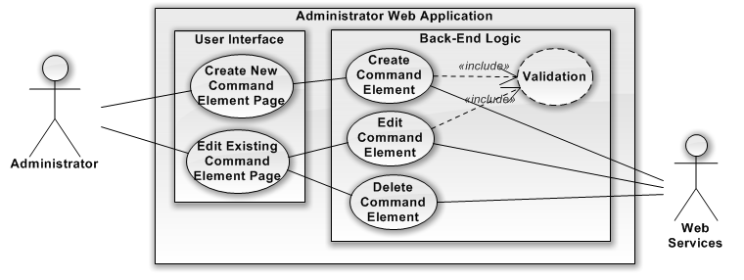

|  |  |
| --- | --- |
| Use Case Name | UC-16: Add / Edit/ Delete Command Element |
| Description | The Administrator can manage all CRUD operations of the Command Element Table |
| Work Products | Admin Web App; |
| Users/Actors | Administrator; Web Services; |
| Assumptions | Administrator is logged in; |
| Preconditions | None; |
| Steps | 01: Use Inputs Needed values for the Command Element  02: User Clicks Submit  03: User Sees Waiting Message  03-01: Validation of all inputted values  03-02: Request made to Web Services  03-03: Response is received and information is parsed.  04: Page is refreshed to show the updated content |
| Variations | AP-03-01: If any fields are invalid, it will output error message to user.  AP-03-02: If can’t connect to database, it will timeout and return error. |
| Postconditions | CRUD Operations is performed on Command Element |
| Exit Criteria | None |

### UC-17: Add / Edit / Delete Command Identifier

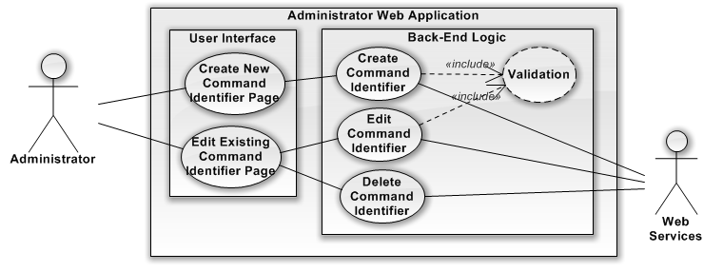

|  |  |
| --- | --- |
| Use Case Name | UC-17: Add / Edit/ Delete Command Identifier |
| Description | The Administrator can manage all CRUD operations of the Command Identifier Table |
| Work Products | Admin Web App; |
| Users/Actors | Administrator; Web Services; |
| Assumptions | Administrator is logged in; |
| Preconditions | None; |
| Steps | 01: Use Inputs Needed values for the Command Identifier  02: User Clicks Submit  03: User Sees Waiting Message  03-01: Validation of all inputted values  03-02: Request made to Web Services  03-03: Response is received and information is parsed.  04: Page is refreshed to show the updated content |
| Variations | AP-03-01: If any fields are invalid, it will output error message to user.  AP-03-02: If can’t connect to database, it will timeout and return error. |
| Postconditions | CRUD Operations is performed on Command Identifier |
| Exit Criteria | None |

### UC-18: Add / Edit / Delete Form Element

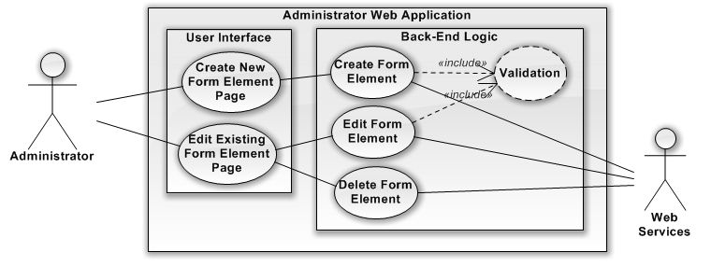

|  |  |
| --- | --- |
| Use Case Name | UC-18: Add / Edit/ Delete Form Element |
| Description | The Administrator can manage all CRUD operations of the Form Element Table |
| Work Products | Admin Web App; |
| Users/Actors | Administrator; Web Services; |
| Assumptions | Administrator is logged in; |
| Preconditions | None; |
| Steps | 01: Use Inputs Needed values for the Form Element  02: User Clicks Submit  03: User Sees Waiting Message  03-01: Validation of all inputted values  03-02: Request made to Web Services  03-03: Response is received and information is parsed.  04: Page is refreshed to show the updated content |
| Variations | AP-03-01: If any fields are invalid, it will output error message to user.  AP-03-02: If can’t connect to database, it will timeout and return error. |
| Postconditions | CRUD Operations is performed on Form Element |
| Exit Criteria | None |

### UC-19: Add / Edit / Delete Form Element Attribute

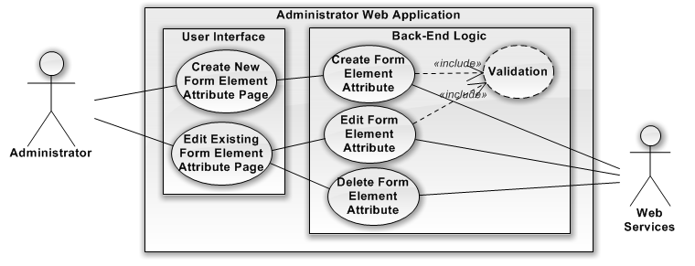

|  |  |
| --- | --- |
| Use Case Name | UC-19: Add / Edit/ Delete Form Element Attribute |
| Description | The Administrator can manage all CRUD operations of the Form Element Attribute Table |
| Work Products | Admin Web App; |
| Users/Actors | Administrator; Web Services; |
| Assumptions | Administrator is logged in; |
| Preconditions | None; |
| Steps | 01: Use Inputs Needed values for the Form Element Attribute  02: User Clicks Submit  03: User Sees Waiting Message  03-01: Validation of all inputted values  03-02: Request made to Web Services  03-03: Response is received and information is parsed.  04: Page is refreshed to show the updated content |
| Variations | AP-03-01: If any fields are invalid, it will output error message to user.  AP-03-02: If can’t connect to database, it will timeout and return error. |
| Postconditions | CRUD Operations is performed on Form Element Attribute |
| Exit Criteria | None |

### UC-20: Add / Edit / Delete Form Element Option

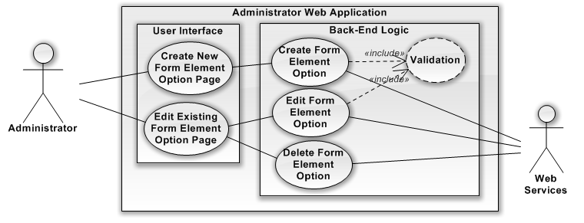

|  |  |
| --- | --- |
| Use Case Name | UC-20: Add / Edit/ Delete Form Element Option |
| Description | The Administrator can manage all CRUD operations of the Form Element Option Table |
| Work Products | Admin Web App; |
| Users/Actors | Administrator; Web Services; |
| Assumptions | Administrator is logged in; |
| Preconditions | None; |
| Steps | 01: Use Inputs Needed values for the Form Element Option  02: User Clicks Submit  03: User Sees Waiting Message  03-01: Validation of all inputted values  03-02: Request made to Web Services  03-03: Response is received and information is parsed.  04: Page is refreshed to show the updated content |
| Variations | AP-03-01: If any fields are invalid, it will output error message to user.  AP-03-02: If can’t connect to database, it will timeout and return error. |
| Postconditions | CRUD Operations is performed on Form Element Option |
| Exit Criteria | None |

### UC-21: Add / Edit / Delete User

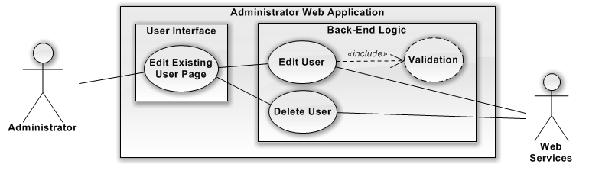

|  |  |
| --- | --- |
| Use Case Name | UC-21: Add / Edit/ Delete User |
| Description | The Administrator can manage all CRUD operations of the User Table |
| Work Products | Admin Web App; |
| Users/Actors | Administrator; Web Services; |
| Assumptions | Administrator is logged in; |
| Preconditions | None; |
| Steps | 01: Use Inputs Needed values for the User  02: User Clicks Submit  03: User Sees Waiting Message  03-01: Validation of all inputted values  03-02: Request made to Web Services  03-03: Response is received and information is parsed.  04: Page is refreshed to show the updated content |
| Variations | AP-03-01: If any fields are invalid, it will output error message to user.  AP-03-02: If can’t connect to database, it will timeout and return error. |
| Postconditions | CRUD Operations is performed on User |
| Exit Criteria | None |